(Organisation) Reimbursement/Expense Request
Name: ________________________________________ Phone: ______________________ Date: ___________________
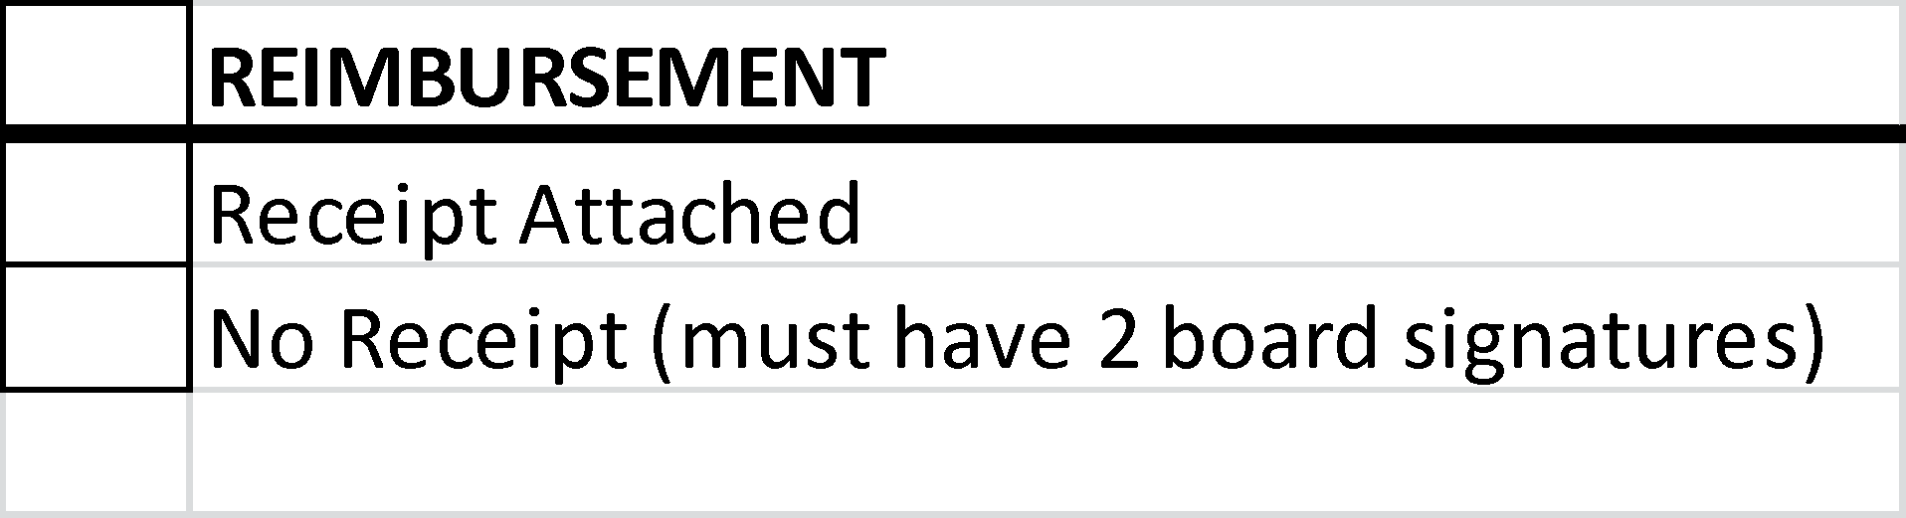
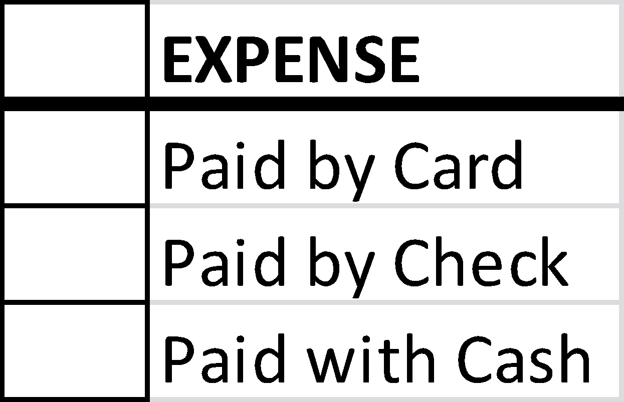
Request Type: Pre-Approved: YES NO

Program/Event: ______________________________________________________________________________________________
Payable/Paid To: ________________________________________________________________ Amount $: ___________________
Purpose of Funds Being Reimbursed (Be Specific): __________________________________________________________________
____________________________________________________________________________________________________________
____________________________________________________________________________________________________________
Requestor Signature: __________________________________ Printed Name: _____________________________________

Board Signature: _____________________________________ Printed Name: _____________________________________

Board Signature: _____________________________________ Printed Name: _____________________________________

Note: Attach all receipts and other applicable supporting documentation (i.e., purchase orders, contracts, etc. to this form)

Instructions
Reimbursements
- Items that have already been approved in the budget can be purchased anytime during the same Financial Year (until June 30)
- A receipt should be submitted and attached to this completed form
- If unavailable to provide a receipt for an amount under $100, you must have two P&C board members (not including yourself) sign.
- Cheques will be made payable to the name on this form.

Expenses
- For signers on the bank account only
- Attach the point of sale receipt of invoice to this form and submit

For Treasurer’s Use Only
Date Paid: ____________Check #: ___________ Category: __________________________ Event: __________________________
Signature: ___________________________________________ Printed Name: __________________________________________

